Integrated Care Board
If you want to make a complaint about primary care services to the commissioner you will now contact the Experience Team within NHS Humber and North Yorkshire Integrated Care Board instead of NHS England.
You can do this by:
Telephone: 01904 555999
E-mail: hnyicb.experience@nhs.net
Writing to us at: The Experience Team
Humber and North Yorkshire ICB
Health Place
Wrawby Road
Brigg
DN20 8GS
Finally, the NHS Commissioning Board can help refer unresolved issues to the independent Parliamentary and Health Service Ombudsman - write to:
Millbank Tower
Millbank
London
SW1P 4QP
Tel: 0345 015 4033 Springbank Health
York Road
Green Hammerton YO26 8BN
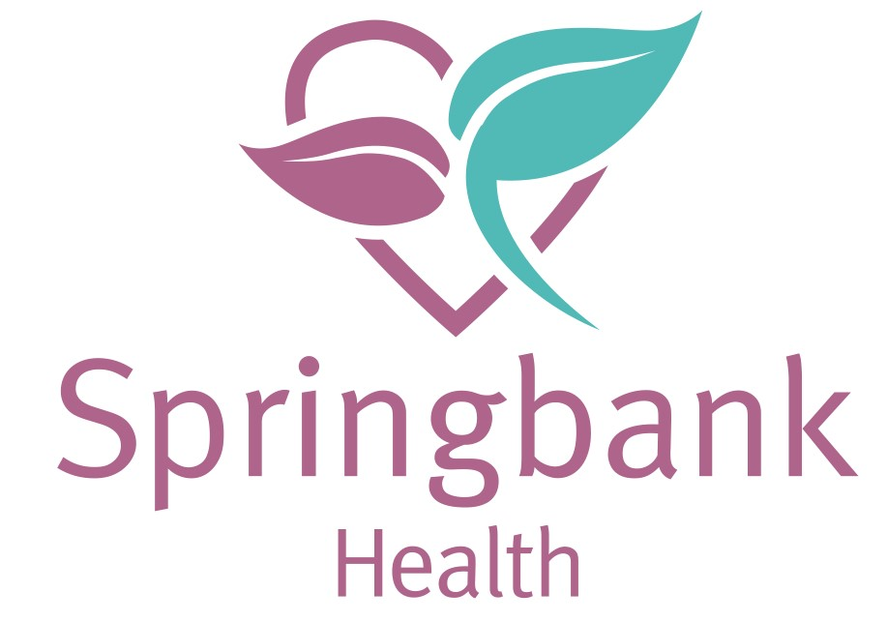
21 Marston Road
Tockwith
YO26 7PR
Tel: 01423 330030 www.springbankhealth.co.uk
Are you happy with our service or feel we need to make an improvement?
We take pride in providing the best possible care. Your feedback helps us achieve this.
www.springbankhealth.co.uk
At Springbank Health, our aim is for patients to feel listened to, understood and respected. We want to provide a caring, efficient service, giving patients the best healthcare advice and treatment.
We like to hear about when we do well but we also need to know when we could do better. We have feedback forms at reception and you can also give feedback on our touchscreens in the surgery corridors or via our patient group. We rely on this feedback to improve our service.

What to do if you have concerns or comments
We hope that most problems can be sorted out easily and quickly, often at the time they arise and with the person concerned. If your problem cannot be sorted out in this way, we would like you to let us know as soon as possible - ideally within a matter of days or at most weeks - because this will enable us to establish what happened more easily. If it is not possible to do that, please let us have details within 6 months of the incident that caused the problem, or within 6 months of discovering that you have a problem.
Letters should be addressed to Mr Danny Young, our Practice Manager. Alternatively, you may write to Dr O'Donoghue, our senior partner. You may wish to ask for an appointment with Mr Young. He will make sure that your concerns are dealt with promptly. It will be a great help if you are as specific as possible.

What we will do
We value all feedback and will take your comments seriously. We will acknowledge your written correspondence within three working days and will provide an overarching response in a reasonable period of time. We will then be able to offer you an explanation, or a meeting with the people involved.
When we look into your concerns, we aim to:
- Find out what happened and what went wrong.
- Make it possible for you to discuss the problem with those concerned if you would like to do this.
- Make sure you receive an apology if this is appropriate.
- Identify what we can do to ensure the problem does not happen again.

Please note that we keep strictly to the rules of medical confidentiality. If you have a concern on behalf of someone else, we will need to know you have permission to act on their behalf. A note signed by the person concerned will be needed, unless they are incapable (because of illness) of providing this.

We hope that if you have a problem, you will allow us to look into it and put it right. We believe that this will give you the best chance of receiving answers and will give us an opportunity to improve our service.

If you need any support articulating your concerns, you can get help and advice from;

North Yorkshire NHS Complaints Advocacy Service
Tower Court, Oakdale Road
Clifton Moor
York YO30 4XL
Telephone: 0300 012 4212
email: helpwithnhscomplaintsnorthyorks@cloverleaf-advocacy.co.uk

